Digital Design

CSCE 2114-L007

Blake Fasse

October 10, 2016

[bafasse@uark.edu](mailto:bafasse@uark.edu)

This lab was split up into two parts. For the first part of the lab the function F(A,B,C) = ∑m(0,3,7) was given and it needed to be converted in sum of products form and used three inverters, three AND gates, one OR gate. That function then needed to be remade using only NAND gates and required three 2 input and four 3 input NAND gates. For the second part of the lab that same function needed to be converted into product of sums form and used three inverters, three OR gates and one AND gate. That then needed to be remade using only NOR gates and required three 2 input and 4 3 input NOR gates.

The purpose of this lab was to understand how to make circuits using only NAND and only NOR gates. The reason the sum of products form of the equation was built using all NAND gates is because all three variables are together are OR together and then AND together after that. The reason the product of sums form was built using all NOR gates was because all three variables are OR together and then AND together. The solution of the product of sums form is also then inverse of the sum of products solution.

As previously stated, the function F(A,B,C) = ∑m(0,3,7) needed to be converted into sum of products form and a circuit needed to be built using only NAND gates for the first part of the lab and the same function needed to be converted again into product of sum form and a circuit needed to be built using only NOR gates. Both of the circuits built from the sum of product and product of sum forms used seven gates, three 2 input and four 3 input gates. For the first part of the lab, seven IC’s were used to build the circuit, three 2 input and four 3 input, due to the fact that it was easier to see which gate was which and made debugging easier. For the second part of the lab only three IC’s, one 2 input and two 3 input, were used, which in hindsight was not a good idea because it made debugging more difficult but allowed for more space on the board.

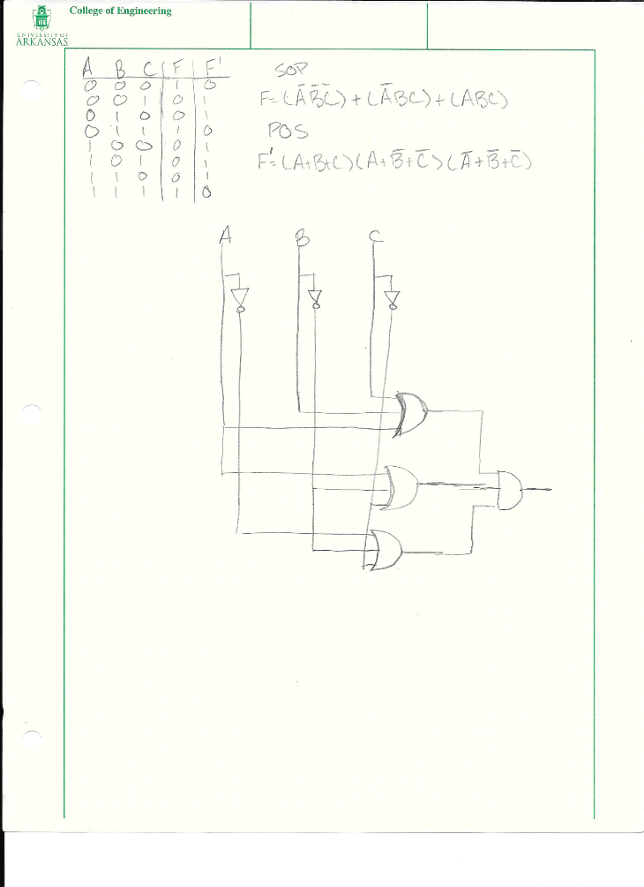

Figure 1: Product of Sums form

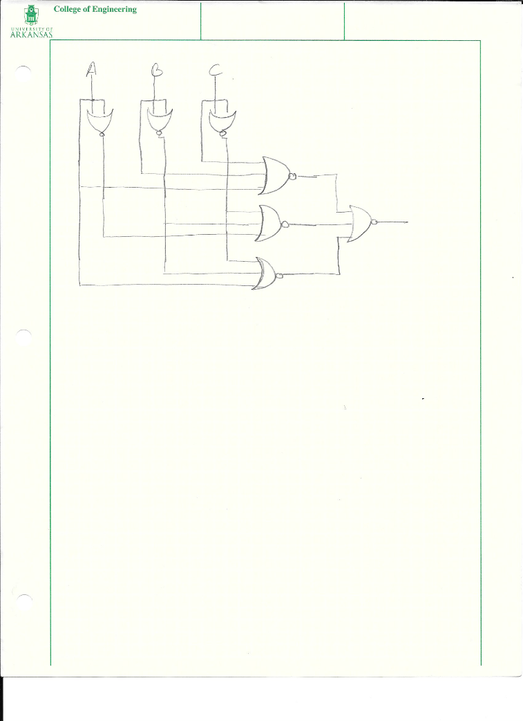

Figure 2: Product of Sums form circuit built with only NOR gates

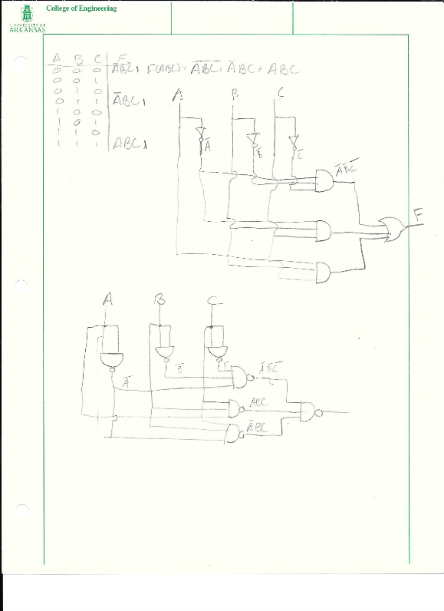

Figure 3: Sum of Prducts form and the circuit built using all NAND gates

The results are as shown in the pictures above. The lab was not able to be completed because for the second part of the lab the circuit was able to be built but, like previously stated, the way the circuit was built it did not make debugging easy. Also due to a lack of knowledge it took a very long time to set up the circuit on the bread board.

The purpose was to implement the function F(A,B,C) = ∑m(0,3,7) in both sum of products and product of sums and then building circuits using only NAND and NOR gates, respectively. This lab was more difficult than the others just because of the amount of time required and a lack of knowledge of the subject.